 W568R-How to setup the wireless settings?
Product line: Wireless Question category: Function configuration

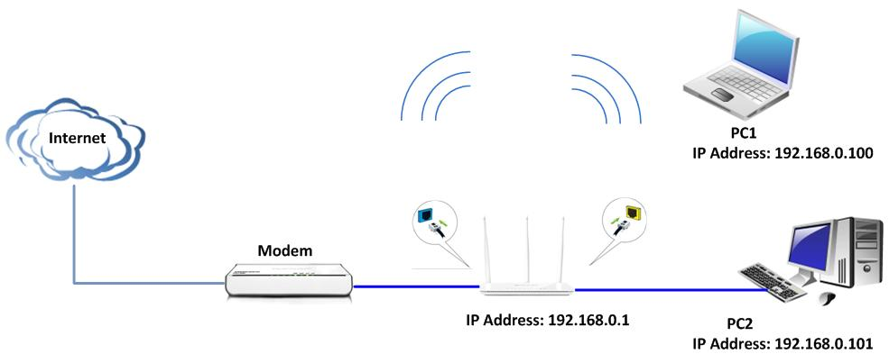
The Steps are as below:
1, Login to the manage page of N80 and go to Advanced. You can change your Wireless Network name (SSID) in Wireless Basic Settings and then click ok.
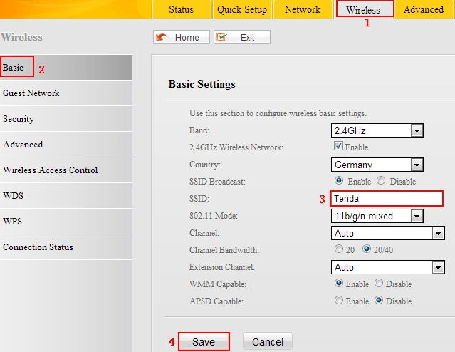
2, Click Wireless→Security to set the password. Please choose WPA-PSK as Security Mode and AES as cipher type. In the blank of the Security key, please type your password which should be at least eight characters, then click save.

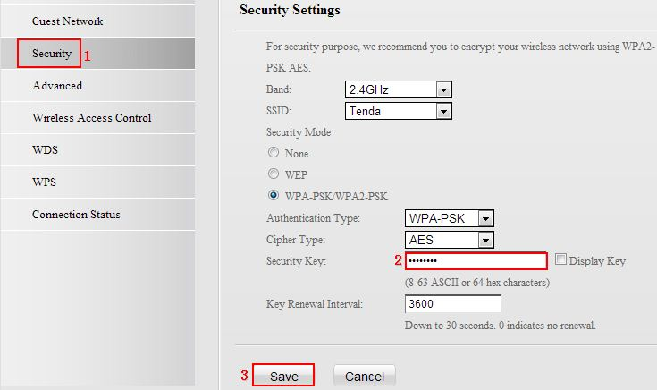

- Please find the name of your wireless network and connect to it. It will require you input password, please type password and click Ok to connect.

